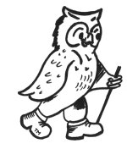

Breakthrough Breast Cancer
The Alternative Cotswolds Challenge
Friday 21st- Sunday 23rd May 2010

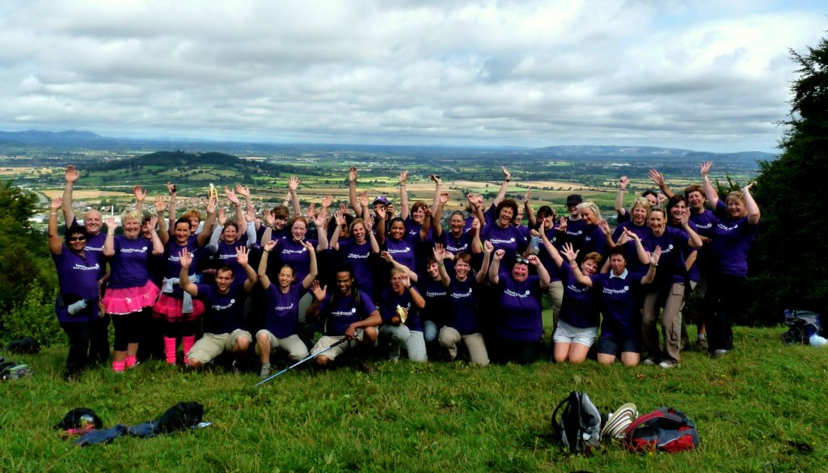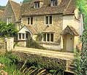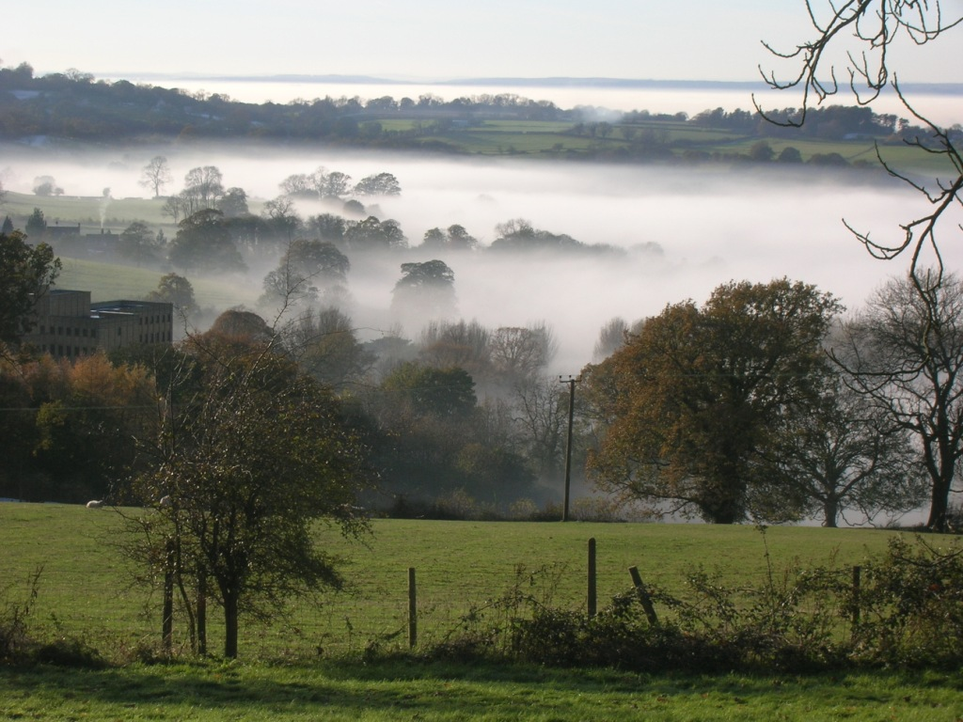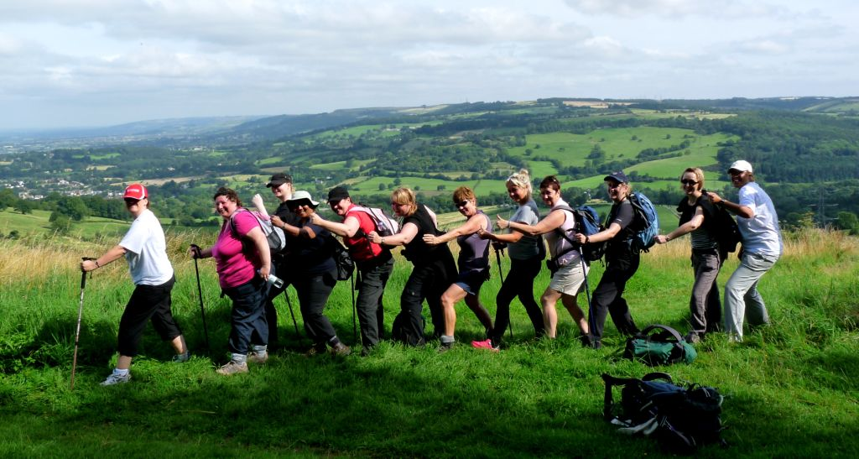

1. The Challenge!
Following the overwhelming successes of the Cotswolds Challenge last year, we’ve decided to run our alternative Cotswolds Challenge for 2010! Put simply our challenge is to complete one of the finest sections of the Cotwsolds Way. In total we will be walking 22 miles over this weekend!!! The route has been chosen quite simply, because it is a great walk in itself. Mostly on good paths, there are also some gently undulating hills to add a bit of a challenge! There is a huge variety of scenery: picturesque villages, beautiful countryside, spring flowering meadows and leafy woodland, and expansive panoramic views from the lofty limestone ridges.

You will be staying in a four star hotel in Cheltenham, complete with swimming pool and leisure facilities, which will be a welcome place to relax after your days walking

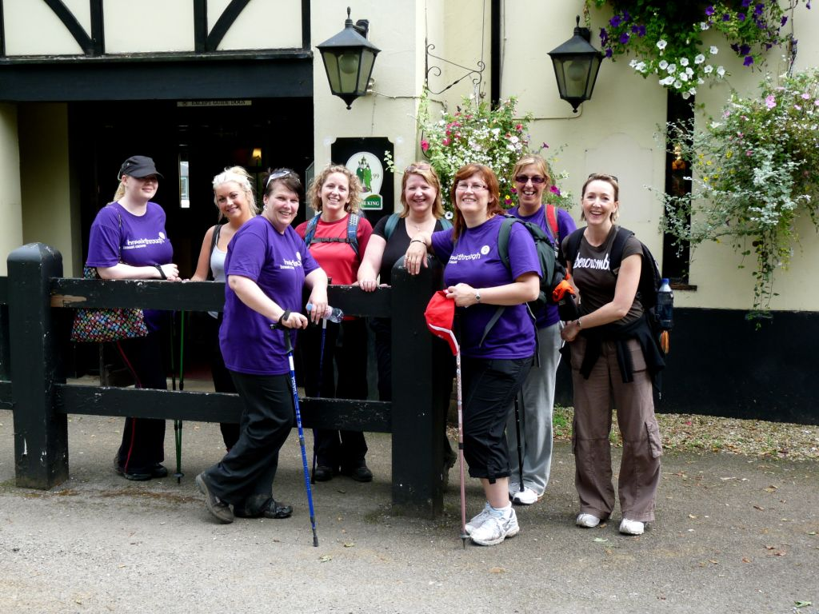
Day 1 Saturday: Mainly along The Cotswolds Way from Painswick to Seven Springs
Today we’ll begin with a coach ride to Paradise! From here there is a short climb up to the wonderful vantage point of Painswick Hill. It is easy to see why this was the site of an extensive fort, as you feel you are perched on top of the world, with a view that stretches for miles in every direction. Our way continues above Prinknash Abbey, to Coopers Hill, famed for ‘cheese rolling’! Onwards to a Roman villa before rejoining the Cotswolds Way. The path now meanders through the lush leafy woodlands to emerge at Birdlip where a short stroll follows to the Air Balloon pub. Now there is a steep climb up to Crickley Hill where our efforts are rewarded with a superb panorama. Staying on the escarpment our path wanders around to Leckhampton Hill and the Devils’ Chimney. By now your thoughts are turning towards the finish and as if by magic the Seven Springs comes into sight!
Distance: 12.5miles (20km), with 1800ft (580m) of ascent.

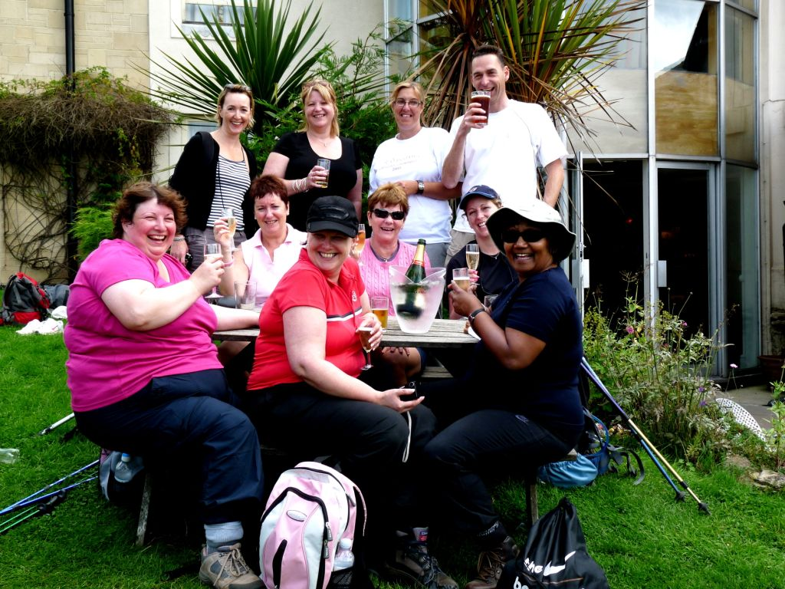
Day 2 Sunday: Limestone escarpments from Seven Springs to Cleeve Hill
To continue our route, the coach will wisk us back to the Seven Springs Inn. Here we’ll begin another lovely picturesque section of the Cotswolds Way. Fortunately there has been a recent alteration to the long distance footpath and we are directed across some fields to re-emerge onto the escarpment. Once again we regain views over the lovely vale of Cheltenham as we head along the ridge to Wistley Hill. This lovely section is mostly on limestone and should be adorned with colourful spring blooms and numerous orchids. Our route is once again full of variation as we descend through Dowdeswell Valley and reservoir before commencing the main climb of the day to Colgate Hill. Eventually the gradient softens and we traverse our way along the slopes before emerging onto the rolling hillsides of our final summit of Cleeve Hill. And what’s at the bottom? The end, the Rising Sun hotel and the chance to reward yourself with a cream tea!
Distance: 10miles (16km), with 900ft (290m

2. Accommodation and what’s included in the price!

Accommodation:
The Cheltenham Thistle Hotel has all the facilities you would expect from a four star hotel and the bedrooms are furnished to high standards, with satellite TV, trouser press, hairdryer plus tea and coffee making facilities. The hotel has the a relaxing coffee bar, a cocktail bar and a very comfortable lounge. Should you have any excess energy, or just like to relax and be pampered there is also a leisure club on site. The Otium Leisure Club comes complete with swimming pool, Jacuzzi, sauna and fully equipped gymnasium, and within the grounds there are two all weather floodlit tennis courts.

Friday Night
We will aim to start the event by meeting everyone in the bar on the Friday night at 7pm. You will have the chance to meet your fellow participants and make some new friends. Dinner will then be served in the restaurant at 8pm. We appreciate that a lot of you will have had long journeys up and it may not be possible to make the 7pm meet. Therefore the main briefing for the Challenge will be after breakfast.

Saturday
Breakfast: 8am
Main Briefing: 9am in the Lounge
Leave by coach to the start of the Challenge: 9:15am
Picnic lunch
Three course dinner: 7pm

Sunday
Breakfast: 8am
Leave by coach: 9am
Picnic lunch

Friday 21st- Sunday 23rd May 2010 | Price per person
Full Package  With 2 nights accommodation  2 breakfasts  2 picnic lunches  2 evening meals  All transport to walks  Professional walking guides | Twin share £150.00 / person  Single £180.00 / person  Please check we have single availability when booking
EXTRA Night  Sunday 23rd May –Monday 24th May 2010  Dinner, Bed & Breakfast | £ 50.00 per person
Event only  2 picnic lunches  1 evening meal  All transport to walks  Professional walking guides | £75.00 per person

3 WalkWise Joining Instructions to

The Thistle Hotel Cheltenham

The WalkWise guides will arrive early evening and are looking forward to meeting you.
- Arrival meal: is set for 8pm, when you will have the opportunity to meet your guides and they will discuss the overall event and walks.
(If you are going to be late for the arrival dinner please advise the hotel and ask them to inform the WalkWise guides).
- Arrival time: any time after 2pm. Should you wish to arrive any earlier please enquire at the hotel directly.
- What to bring: To ensure that you are properly equipped, please take a moment to read through the ‘What to bring list’ and ensure that you have the necessary clothing and equipment.

Thistle Cheltenham, Gloucester Road
Cheltenham GL51 0TS
Reception: 01242 232 691
email: Cheltenham@Thistle.co.uk
web: www.thistlehotels.com/cheltenham

Directions

Road
From London, take the M4 towards Wales and leave at Jn 15 (Swindon). Pick up the A419 towards Swindon and Cirencester, which then turns into the A417, signed Gloucester. Follow the A417 to the M5 and head for the Midlands. Come off at Junction 11 (one junction up) and take the A40 (third exit) towards Cheltenham. At next roundabout take 2nd exit. The hotel is immediately on left with parking to the front and rear. There are 220 spaces available at no charge.

M5
By Car the Thistle could not be easier to find. From M5, junction 11. Take the A40 (third exit) towards Cheltenham. At next roundabout take 2nd exit. The hotel is immediately on left with parking to the front and rear. There are 220 spaces available at no charge.

Railway and the Tube
Cheltenham rail station is 1.5 miles away.

Check In Notice
From 14:00, if rooms are available earlier we will be happy to check you in
If you have any problems in finding the hotel or are not going to arrive in time for the 8pm arrival meal please give us a ring
Useful Telephone numbers:
The hotel 01242 232 691
Andrew 0774 489 2263 (guide)
Gideon 0780 907 0257 (guide)

4 What to bring:
You MUST have:
- Walking boots
- A Water bottle (minimum 1 litre)
- A Rucksack with a plastic liner
- Waterproofs: jacket and trousers
- A Warm hat
- Warm gloves (not leather)
- Thick walking socks
- Base layer: (thin thermal or warm T-shirt, not to be cotton as it gets cold when wet)
- Over layer: (warm sweater or fleece)
- Extra layer: warm top for when cold (eg. when stopped for lunch)
- Comfortable walking trousers (not jeans as they are too cold & heavy when wet)
- Personal Medication
- Smart casual clothes for the evening.

You may wish to bring:
- Vacuum flask (if you like hot drinks on the hill)
- Medium size Tupperware container or plastic bag, to put picnic lunch in.
- Sit mat
- Sun glasses
- Lip salve
- Camera
- Personal first aid kit
- Trekking poles

In good weather and/or summer, you may also wish to bring
- Short trousers
- T - Shirts
- Sun hat
- Sun tan lotion

If you would like a map for the event, walkwise can now offer you some special deals, please visit www.walkwise.co.uk and use the link to get 10% off your order and see the latest special offers. The maps you will need for this weekend are

Explorer 179 Gloucester, Cheltenham and Stroud

5. Preparing yourself for the Event

The Cotswolds Challenge is a physically demanding event. You will be walking in the hills for two days and each of these days will consist of up to 12 miles with some ascent and descent as well. If you are not used to walking, or taking regular exercise, then you ought to prepare yourself.

Your body needs breaking in and occasional maintenance too! If you prepare yourself gradually you will enjoy the event even more. It is best, less painful and much easier to build up your fitness levels gradually! If you exercise regularly, go swimming, play squash once a week or consider yourself to be averagely fit already, then you have a good starting point, but it is best get used to walking as well. Following these guidelines will help your body prepare for the event:

Getting used to your Boots!
Simply walking around your home and going shopping in your boots will allow your feet to get used to them. This will help to prevent unnecessary blisters and pain, almost always a good thing. Nevertheless, this is not sufficient, it is useful to prepare yourself a little bit more, and the best way to do this is to walk!

Building up your Fitness
The simplest changes in your everyday life can make the biggest difference.
- If you are popping out to the shops, then slip into your boots and walk instead of taking the car.
- If you go to work on the bus or tube, make a resolution to walk to the next stop or get off a stop early.
- Once a week during your lunch hour take a brisk walk around the park.
- To get yourself used to ascent and descent, make a resolution not to use the lift! Using the stairs regularly is a very effective tool in preparing your body for climbing in the hills.

Go on some half day walks
To build up your stamina, it is a good idea to actually go on a walk! On a couple of days off, have a walk in the park or go the local countryside. Buy a local guide book of short walks, perhaps get some friends together and just do it! Walks which end with a pub lunch seem to be extremely popular!
Try to do 2 or 3 half-day walks over the next few months and gradually build up the distance you do.

Try some full day walks
After doing some half-day walks, try a couple of full day walks. Keep increasing the distance until you feel happy with your own ability.

This is the best and most effective way to prepare yourself for the event.
Remember the event is not a flat out race, it is fun challenge event
and a good fitness level will help you to get the most out of it!

6. How to Book and Booking Conditions

- Any provisional booking will be held for 14 days pending receipt of your deposit.
(the deposit of £50.00 is non refundable)
- Your place is secured only when WalkWise UK Ltd receive your deposit
- cheques are to be made payable to WalkWise UK Trust Account
- The balance must be received 8 weeks prior to the start date of the event
- Cancellation
Up to 8 weeks prior to the event, you cancellation will result in loss of deposit. Thereafter the following cancellation charges will apply.
cancellation up to 6 weeks prior 50% of the price
cancellation up to 3 weeks prior 75% of the price
cancellation up to 2 weeks prior 100% of the price.
- The event will be operated by WalkWise UK Ltd.
Their company address is
WalkWise UK Ltd
30 GreenWays Drive Endmoor Kendal LA8 0EL
Tel Fax 01539 560 911
e-mail : holidays@walkwise.co.uk
www.walkwise.co.uk

7 Insurance
The most comprehensive insurance policy that seems to be available at a sensible cost is via the post office. We recommend that every participant takes out insurance, but with such competitive rates on the high street it is best to pick up it individually.

8 room list

Cotswolds Challenge | Bedding List | WalkWise UK Ltd
BBC |  | 56 pax in total
21st May 2010
single | name
single 1*
single 2 *
single 3 *
single 4 *
single 5
single 6
single 7
single 8
single 9
single 10
Single 11
Single 12
twin rooms | name | name
twin 1 *
twin 2 *
twin 3 *
twin 4 *
twin 5 *
twin 6
twin 7
twin 8
twin 9
twin 10
twin 11
twin 12
twin 13
twin 14
twin 15
twin 16
twin 17
twin 18
twin 19
twin 20
Twin 21
Twin 22
Twin 23
* room held for 3 nights

