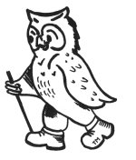
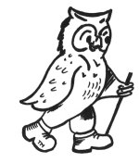
3. Walking Weekend Norfolk Broads and Coast

Joining Instructions to Burlington Palm Hotel, Great Yarmouth

On behalf of all the WalkWise team, thank you for booking your walking event! The WalkWise guides will arrive early evening and are looking forward to meeting you.

Meet up in the bar from 7pm where you can meet your fellow participants and your guides.
Arrival meal: is set for 8.00pm when you will have the opportunity to meet your guides and they will discuss the overall event and walks.
(If you are going to be late for the arrival dinner please advise the hotel or leaders on the contact numbers below!)
Arrival time: any time after 4pm. Should you wish to arrive any earlier please enquire at the centre directly.
What to bring: To ensure that you are properly equipped, please take a moment to read through the ‘What to bring list’ and ensure that you have the necessary clothing and equipment.

Directions:
Burlington Palm Hotel, North Drive, Great Yarmouth, Norfolk, NR30 1EG
Telephone 01493 844568

By Car:
Take A47 into Great Yarmouth, then at the roundabout take the A149 following signs for sea front. Continue on as this becomes the B1141 (Fullers Road and Euston Road) and continue following signs to the sea front. When you reach the seafront turn LEFT along North Drive (with the sea on your Right) and in 300m you will see the Burlington Palm Hotel on your LEFT.
By Rail
From London Liverpool Street station there is a train into Great Yarmouth. Journey usually takes 2.5 hours. The train station is approximately 10 minutes taxi journey from the station.

Tourist Information Centre 01493 846 346

National Express:
Services available to Great Yarmouth. National Express enquiries 08705 808080.

By Taxi:
Taxi ranks at railway station,

If you are having problems finding the hotel, please call them directly, or you could call one of your guides:

Gideon Wheater 0780 907 0257
Andrew Casey: 0774 894 2263

Whilst every effort has been taken to ensure your trip is enjoyable, occasionally unforeseen difficulties may arise. Should you have any concerns please raise them with your guides at the time. They will then endeavour to resolve them swiftly so that you can enjoy your trip.

Maps Deal: If you would like a map for this event, The map(s) for this event are:
1:25 000 OL250 Norfolk West Coast

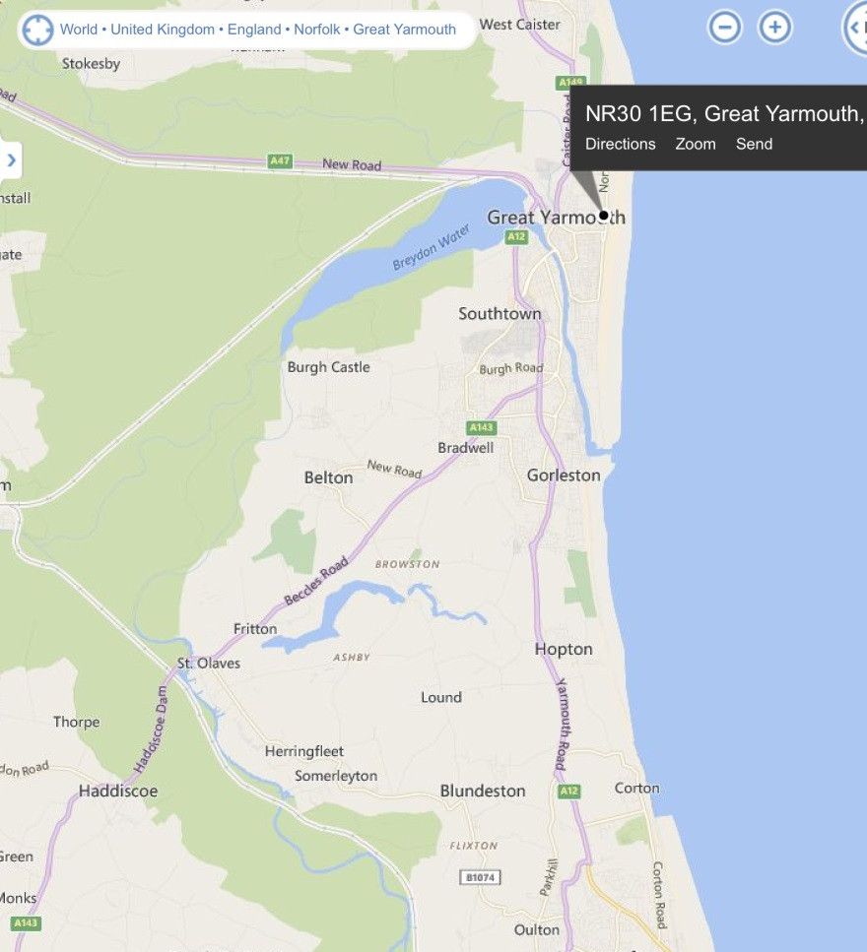

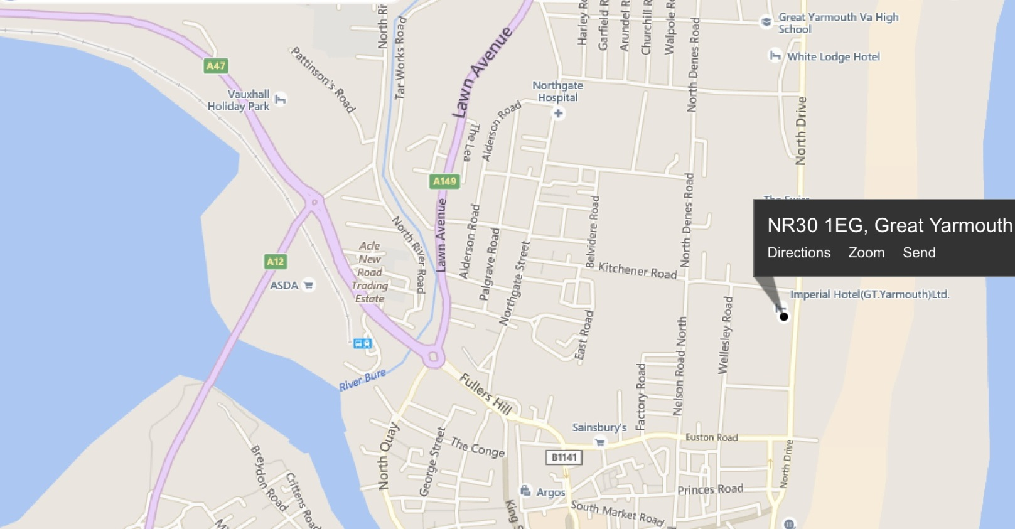

4. What to bring:

You MUST have:
- Walking boots
- A Water bottle (minimum 1 litre)
- A Rucksack with a plastic liner
- Waterproofs: jacket and trousers
- A Warm hat
- Warm gloves (not leather)
- Thick walking socks
- Base layer: (thin thermal or warm T-shirt. Best not to be cotton as it gets cold when wet)
- Over layer: (warm sweater or fleece)
- Extra layer: warm top for when cold (eg. when stopped for lunch)
- Comfortable walking trousers (not jeans as they are too cold & heavy when wet)
- Any Personal Medication
- Casual clothes for the evening.

You may wish to bring:
- Vacuum flask (if you like hot drinks on the hill)
- Medium size Tupperware container or plastic bag, to put picnic lunch in.
- Sit mat
- Sun glasses
- Lip salve
- Camera
- Personal first aid kit
- Trekking Poles

In good weather and/or summer, you may also wish to bring
- Short trousers
- T - Shirts
- Sun hat
- Sun tan lotion

In poor weather and/or winter, you may also wish to bring:
- Extra warm clothing

