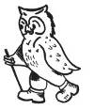
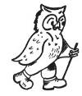
Scottish Walking Week
The Western Isles: Harris, Lewis Taransay & North Uist
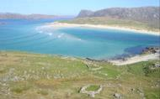
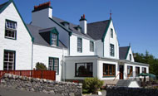
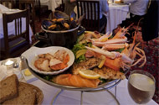
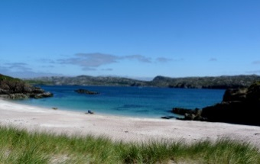
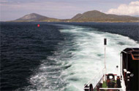

Date : Saturday 25th July 2015 to Saturday 1st August 2015
Place : The Harris Hotel, Isle of Harris, HS3 3DL
Cost : £799.00 per person in shared room
£200.00 per person Double for sole use supplement
Room upgrades available contact Gideon@walkwise.co.uk
Includes : 7 night’s accommodation, 6 evening meals, 7 breakfasts, 5 picnic lunches.
5 full days professional guiding offering two walks each day
Not Included : Transport to and from walks. Cost of ferrys to the islands
Dinner on the rest day. Travel Insurance, room upgrades
Places: Up to 36, 10 Doubles en suite for sole use, 8 twin en suite rooms, 5 double en suite rooms

Overview: The Western Isles of Harris, Lewis, North Uist and Taransay are part of the outer Hebrides archipelago. These mysterious islands are steeped in thousands of years of history, folk law and legend with stone circles, brochs, castles standing alongside todays towns and villages. Each island has its own unique character, as diverse and varied as the surrounding landscape where spectacular white beaches, delightful inlets, peaceful bays are set against a backdrop of the rugged machair with the high mountains behind. The islands total over 600 square miles yet are populated by just a few thousand, friendly and warm islanders. This leaves lots of peaceful space that is ideal for the wildlife; soaring eagles, playful otters, herds of red deer and feral goats, dolphins and even the occasional passing whale can all be seen. When you combine the peace, space, the scenery and the warmth and quiet confidence of the people, you get the uniqueness of the western isles and you can rest assured that the memory of one visit to these magical islands will stay with you forever, but it is unlikely that one visit will be enough…

There is little accommodation on the islands, but for this wonderful trip walkwise have secured the wonderful Harris Hotel in Tarbert, which offers traditional island hospitality, superb food and a relaxing atmosphere. Our fantastic hosts will look after our every need as we head out to explore the islands!

WalkWise Walking Programme: So what delights lie ahead for us! Well there is so much to see and do on the islands that whatever we do we will only just scratch the surface. Our programme is designed to give everyone a flavour of the islands of Lewis, Harris, South Uist and Taransay, the wide variety of habitats, the inviting beauty, the history and the rugged mountains. Each day we will have two grades of walk, usually in a similar area, with the tougher walkers heading out over wilder and rougher terrain whilst the easier walkers explore the region on easier but no less spectacular routes.
Harris is a stunning island in itself, with some of the finest beaches in the UK adorning its western coast. This is set against the large open machair areas and contrast with the east coast which is typified by isolated inlets and rugged bays. The north of Harris changes again becoming much more mountainous and wild with sea lochs cutting into the heart of the mountains. It is here that the harder walker will ascend the Clisham Ridge which leads up to the archipelagos only Corbett An Clisheam at 799m; a spectacular ridge walk with superb views over the whole of Harris. The easier walkers also get to savour this region with remote glen walks that cut through this wild and empty region.

One day will see us sailing out a couple of miles off the west coast of Harris to the isle Taransay. This small island was made famous by Castaway in 2000 (tv programme), but thankfully its sleepy image has returned. The island has some fine sandy silver sand beaches, rock arches, long abandoned villages and these can be combined with the lovely ascent of Beinn na h-Uidhe which should be ascended as affords stunning views back across the island to Harris. For those that are feeling energetic there is a second peak on the island, the islands highest peak, Beinn Ra which has stunning views across the loch to the Mountains of the north. The island has one last treat in store as it has been cleared of Mink and now has breeding population of puffins and Shelduck.

Some days will see us driving north to the Isle of Lewis, which sounds odd, but the isles of Lewis and Harris are actually joined. However, whilst the isle of Lewis is flatter than Harris but is coastline is equally spectacular with coastal inlets eating away into the island and rugged cliffs providing home to thousands of seabirds. We will most likely undertake two of our favourite coastal walks, which feature the dramatic lighthouses of Tiumpan and Seileir Heads set to the symphony of the constantly crashing of the waves .

And finally there is North Uist, which an island and weather is permitting we will hop over on the ferry to explore it. Once again it has a varied character and the easier walkers cross the sand dunes to walk the beaches of the northwest of the island before making their way back through the harbours and inlets of the east of the island. Meanwhile the harder walkers will pick their way around the numerous lochans to ascent the isolated peak of Eaval and enjoy its amazing panoramic view!

So whether you fancy a lower level or a higher level walks you wont be disappointed. The only difficulty is deciding which one to do! So why not come and join us on a week of discovery, nature, laughter and the pleasure of enjoying it with like minded people. Remember to allow you to choose a walk that suits you best, WalkWise will provide two walks on each day, led by professional and knowledgeable walking guides. On all walking days there will be a harder walk of 11 miles with up to 3500ft ascent, and a gentler moderate walk of 7 to 10 miles long with up to1500ft. On certain days our journey will take us past some real gems of the islands and if people wish we may well pause our journeys to explore them too.

Accommodation: A warm welcome awaits you at the Harris Hotel which has been a family owned and run hotel for over 100years. It is situated in Tarbert, which is the ideal base from which explore Harris, Lewis and even the Uists to the south. They offer traditional island hospitality, superb food and a relaxing atmosphere, and you canl be assured of an enjoyable and memorable stay, for all the right reasons! Here you can unwind in comfortable and peaceful surroundings and allow the islands to work their magic; inspire dreams, charge passions and enliven your senses. The hotel has two sun-lounges for guests to relax in, a small television lounge and a small library and a compendium of board-games for your enjoyment. There is even a drying room! There is free WI-FI internet connection in all the downstairs areas for those with their own lap-tops.
All the bedrooms rooms are different, and have been individually decorated, but there are four different classifications of rooms from standard to delux, some with sea views. All rooms have flat-screen televisions, hair dryers and hot drinks tray. Nb For an additional surcharge you can upgrade your room contact Gideon@walkwise.co.uk for prices and availability

Getting there!
Normally we leave all the details about getting there in the joining instructions but if you want a quick heads up! There are car ferrys from the isle of Skye to Tarbert, or from Ullapoos to Stornoway (the ferrys are operated by Calmac, www.calmac.co.uk – the operate on a road equivalent tariff, so it doesn’t cost a fortune). Alternatively you can fly to Stornoway from:Glasgow, Edinburgh, Aberdeen and Inverness, there you’d have to get a connecting flight to elsewhere in the uk and you may want to hire a car in Stornoway too
For more details about this walking week, go to www.walkwise.com and look for the trip under walking events.

Maps: If you would like a map for this event, reduced prices are available by going to www.walkwise.co.uk, and clicking on the Aqua3 Map Deal button. This will take you to the Aqua3 website, from where you can order.
The map for this event are: 1:25 000 454 N.Uist, 455 S. Harris, 456 N. Harris, 458 W. Lewis, 460 N. Lewis
1:50 000 8 Stornoway & N Lewis, 13 West Lewis, N Harris, 18 Sound of Harris

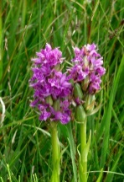
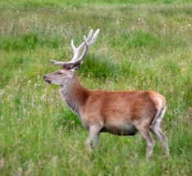
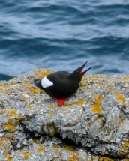
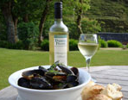
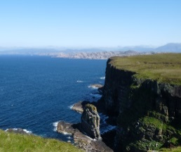
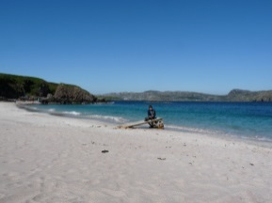
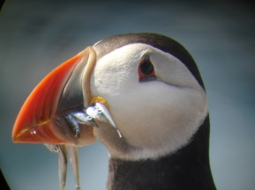
This event is organized and supplied by WalkWise UK Ltd, whose terms and conditions apply, obtainable on request and for whom your local SPICE group acts as an agent. Those booking enter into a contract directly with WalkWise UK Ltd. For availability and bookings contact your local SPICE group directly. For availability and bookings contact your local SPICE group directly or go to http://www.walkwise.co.uk/spice-terms-and-conditions.html

