

WalkWise Joining Instructions to

The Headlands Hotel and Spa

On behalf of all the WalkWise team, thank you for booking your walking event! The WalkWise guides will arrive early evening and are looking forward to meeting you.

- Arrival meal: is set for 08:00 pm when you will have the opportunity to meet your guides and they will discuss the overall event and walks.
( If you are going to be late for the arrival dinner please advise the hotel or leaders on the contact numbers below!)
- Arrival time: any time after 04:00 pm. Should you wish to arrive any earlier please enquire at the centre directly.
- What to bring: To ensure that you are properly equipped, please take a moment to read through the ‘What to bring list’ and ensure that you have the necessary clothing and equipment.
- Leisure facilities Remember the hotel has a sauna, spa and hydro beauty room and a mini gym. To book any treatment please contact the friendly reception team on
01803 295666 or email info@headlandtorquay.com
- If you would like a map for the event, the maps you will need for this weekend are
OL 20 South Devon
Explorer map 110 Torquay and Dawlish

Address: Headland Hotel & Spa, Daddyhole Road, Torquay,Devon TQ1 2EF
Telephone: T: +44(0) 1803 295666
F: +44(0) 1803 211175
Email: info@headlandtorquay.com

Andrew: 0774 894 2263
Gideon: 0780 907 0257

Whilst every effort has been taken to ensure your trip is enjoyable, occasionally unforeseen difficulties may arise. Should you have any concerns please raise them with your guides at the time. They will then endeavour to resolve them swiftly so that you can enjoy your trip.

Tourist information Centre: 0870 70 70 010

Directions: By train: The closest train station is Torquay, for all train enquiries please call 08457 48 49 50

By Car
From the North, follow the M5 to its end at Junction 31, then follow the A38 for 4.1 then turn LEFT singed Exeter Racecourse DunChideock then keep left at the roundabout towards the A380. In one mile keep left towards the A380 and then merge with onto the A380. In 2.4 miles take the exit towards Teignmouth on the B3192. Follow the B3192 for 4.2 miles then turn RIGHT onto Bitton Park Road, the A379. In 0.4 miles turn Left to stay on the A379 signed Torquay Shaldon and follow for 7.6 miles.

Now turn Left onto Lisburne Square. Then Right onto Higher Woodfield Road. In 0.4 mile continue straight onto Parkhill road and then in 0.1 miles turn LEFT into Daddhole Road and the hotel is on your left
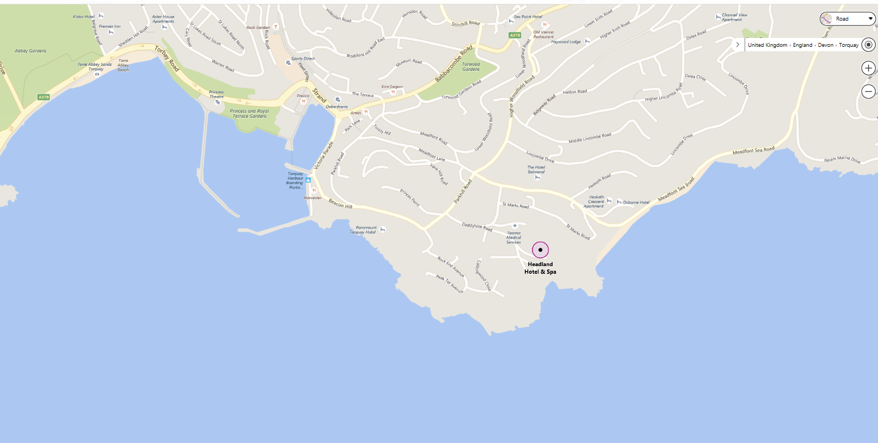

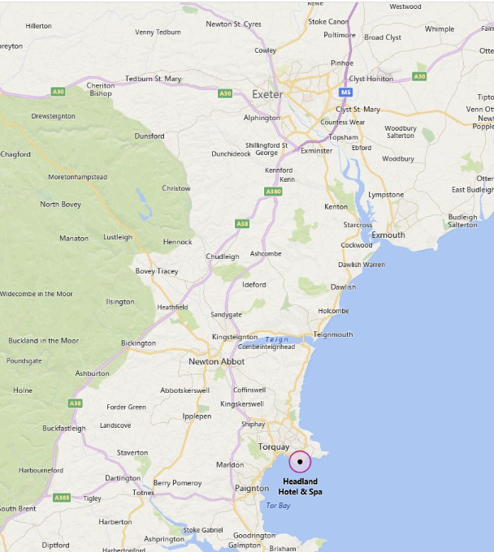

What to bring:
You MUST have:
- Walking boots
- A Water bottle (minimum 1 litre)
- A Rucksack with a plastic liner
- Waterproofs: jacket and trousers
- A Warm hat
- Warm gloves (not leather)
- Thick walking socks
- Base layer: (thin thermal or warm T-shirt. Best not to be cotton as it gets cold when wet)
- Over layer: (warm sweater or fleece)
- Extra layer: warm top for when cold (eg. when stopped for lunch)
- Comfortable walking trousers (not jeans as they are too cold & heavy when wet)
- Personal Medication
- Smart casual clothes for the evening.

You may wish to bring:
- Trekking Poles
- Vacuum flask (if you like hot drinks on the hill)
- Medium size Tupperware container or plastic bag, to put picnic lunch in.
- Sit mat
- Sun glasses
- Lip salve
- Camera
- Personal first aid kit

In good weather and/or summer, you may also wish to bring
- Short trousers
- T - Shirts
- Sun hat
- Sun tan lotion

In poor weather and/or winter, you may also wish to bring:
- Gaiters
- Extra warm clothing

